U.S. NEWS

AUG. 1, 2024 / 4:43 PM

VA launches expanded burn pit registry with automatic inclusion for many vets
By Don Jacobson

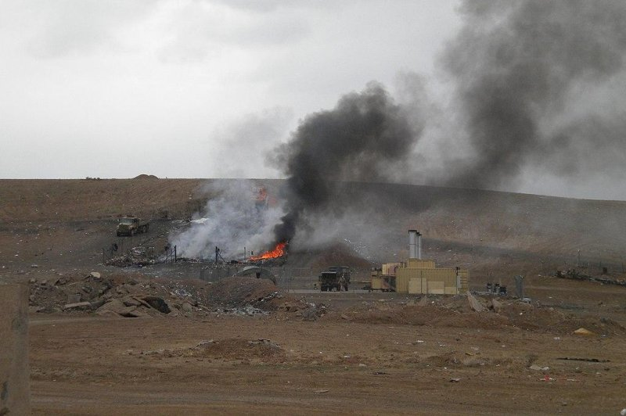
Many U.S. service members who served near open burn pits used by the military in overseas operations, such as the one pictured here at Camp Holland near Tarin Kowt, Afghanistan, in 2010, will now be automatically entered in a revamped Airborne Hazards and Open Burn Pit Registry. Photo by Piero/Wikimedia Commons
Aug. 1 (UPI) -- The Department of Veterans Affairs on Thursday launched an anxiously awaited redesign and expansion of its Airborne Hazards and Open Burn Pit Registry, established 10 years ago to document possible exposure to toxic substances.
Biden administration officials said the move represents an "important milestone" in the federal government's efforts to refine the database, which was set up to understand, research and ultimately improve treatment for the health challenges facing veterans exposed to airborne hazards and burn pits during their military service.
ADVERTISEMENT
Since 1990, some 3.5 million veterans have served in areas that potentially exposed them to airborne hazards and open burn pit toxins, which have been associated with health problems.
Under the biggest change made following years of "extensive feedback" from veterans, the burn pit registry has "massively expanded" its participation criteria and will now automatically include participants from U.S. military operations and campaigns over the last 34 years, including Desert Shield and Desert Storm, Iraqi Freedom, Enduring Freedom and New Dawn.

Related
- Veterans Affairs' burn pit registry needs improvement, officials say
- Bipartisan Senate vote sends burn pit benefits bill to Biden's desk
- Senate Republicans under criticism after blocking burn pit benefits bill
The data to be automatically entered in the registry includes deployment locations, military personnel information, and demographics to include gender, race, and ethnicity.
No medical information will be stored in the registry, and veterans have the right to opt out of the process, VA officials said Thursday.

